FOCUS ACADEMY

Kg to 12

English&Gujarati Medium

|  |  |
| --- | --- |
| BRANCH 1- 19-B MUSLIM SOC, B/H FIRDOS MASJID DANILIMDA AHMEDABAD | BRANCH2-OPP MEMON HALL, JUHAPURA AHMEDABAD |

ALMAS AHMAD SHAIKH [B.SC, B.ED] 12 YEARS EXPERIENCE

Contact No- 9099818013 8780997670

Sub- English grammar Topic- Question tag

Question tags are formed with the auxiliary or modal verb from the statement and the appropriate subject.

A **positive** statement is followed by a **negative** question tag.

* Jack **is** from Spain, **isn't**he?
* Mary **can** speak English, **can't** she?

A **negative** statement is followed by a **positive** question tag.

* They **aren't**funny,**are**they?
* He**shouldn't** say things like that,**should**he?

When the verb in the main sentence is in the [*present simple*](https://www.grammar.cl/Present/Simple.htm) we form the question tag with [**do / does**](https://www.grammar.cl/Present/Do_Does.htm).

* You *play*the guitar, **don't**you?
* Alison *likes*tennis,**doesn't**she?

If the verb is in the *past simple* we use **did**.

* They *went* to the cinema, **didn't** they?
* She *studied* in New Zealand, **didn't** she?

When the statement contains a word with a **negative** meaning, the question tag needs to be **positive**

* He **hardly ever** speaks,**does**he?
* They **rarely** eat in restaurants, **do** they?

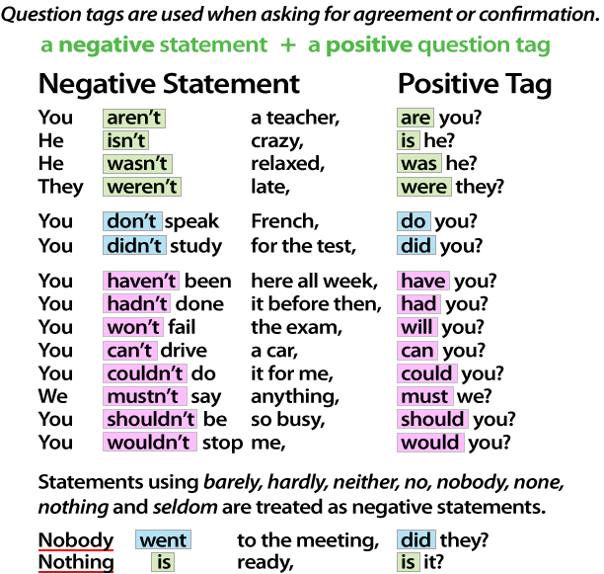

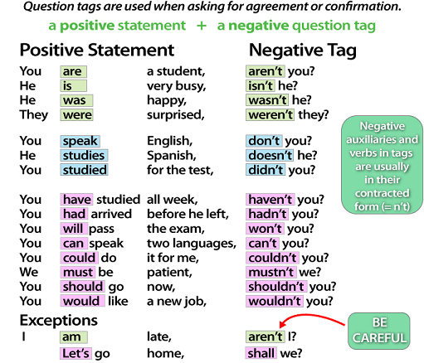

Some more examples-

1. I’m right, **aren’t I?**  
2. Shut up, **can’t you / can you / will you?**  
3. Don’t forget, **will you?**  
4. Move a bit, **would you / will you / can you?**  
5. Let’s go for a walk, **shall we?**  
6. You never say what you are going, **do you?**  
7. There is little we can do about it, **is there?**  
8. Somebody wanted a pizza, **didn’t they?**  
9. He has a daughter, **hasn’t he / doesn’t he?**  
10. There weren’t any issues,**were there?**  
11. Ravi wants to be an actor, **doesn’t he?**  
12. Julia visited you yesterday, **didn’t she?**

13.She is collecting stickers, **isn't she**?

14.We often watch TV in the afternoon, **don't we**?

15.You have cleaned your bike, **haven't you**?

16.John and Max don't like maths, **do they**?

17.Peter played handball yesterday, **didn't he**?

18.They are going home from school, **aren't they**?

19.Mary didn't do her homework last Monday, **did she**?

20.He could have bought a new car, **couldn't he**?

21.Kevin will come tonight, **won't he**?

22.I'm clever, **aren't I**?

# Question Tags Worksheet

**Add question tags to these statements to make questions:**

1 You come from China,

2 He had to leave at 7 o'clock,

3 She hasn't got a dog,

4 It isn't snowing,

5 Jenny was hoping to come,

6 It's stopped raining,

7 He'd better come on time,

8 We've done this before,

9 You don't like football,

10 She won't be late,

11 Annie's French,

12 It was last week that we met,

13 That's wrong,

14 You'd never have thought it,

15 The sun will be shining tomorrow,

16 He'd rather go home,

17 He can't sing,

18 You should leave earlier,

19 I must stop,

20 Let's start,