FOCUS ACADEMY

Kg to 12

English&Gujarati Medium

|  |  |
| --- | --- |
| BRANCH 1- 19-B MUSLIM SOC, B/H FIRDOS MASJID DANILIMDA AHMEDABAD | BRANCH2-OPP MEMON HALL, JUHAPURA AHMEDABAD |

ALMAS AHMAD SHAIKH [B.SC, B.ED] [12 YEARS EXPERIENCE]

CONTACT NO- 9099818013 8780997670

**SCIENCE CLASS- 7 CHAPTER- 10 TO 16 SOLUTION**

CH-10 RESPIRATION IN ORGANISMS

Exercise Questions

[1.] Why does an athlete breathe faster and deeper than usual after finishing the race?

Solution: Athletes need a lot of energy during the race, and for the release of energy, they need a lot of Oxygen; hence they breathe faster than usual after finishing the race.

[2.] List the similarities and differences between aerobic and anaerobic respiration.

Similarities: In both kinds of respiration, food particles are broken down to release energy

Both occurs inside the cells

Both supply by-products

[3.] Why do we often sneeze when we inhale a lot of dust-laden air?

Solution: When we inhale dust-laden air, the dust irritates the nose; as a reflexive action, dust is thrown out through sneezing.

[4.] Take three test-tubes. Fill ¾th of each with water. Label them A, B and C. Keep a snail in test-tube A, a water plant in test-tube B and in C, keep snail and plant both. Which test-tube would have the highest concentration of CO2 ?

Solution: Test tube A will have the highest concentration of CO2 because test-tube A will have Snail which expels out CO2 into the tube. Since a plant is present in both test tubes B and C, the plant will inhale CO2 to decrease CO2 concentration. Thus, there will be less concentration of CO2 in these tubes.

**[5.] Tick the correct answer:**

**(a) In cockroaches, air enters the body through**

**(i) lungs (ii) gills (iii) spiracles (iv) skin**

**(b) During heavy exercise, we get cramps in the legs due to the accumulation of**

**(i) carbon dioxide (ii) lactic acid (iii) alcohol (iv) water**

**(c) Normal range of breathing rate per minute in an average adult person at rest is:**

**(i) 9–12 (ii) 15–18 (iii) 21–24 (iv) 30–33**

**(d) During exhalation, the ribs**

**(i) move outwards (ii) move downwards (iii) move upwards (iv) do not move at all**

**[6.] Match the items in Column I with those in Column II:**

**Answer:**

|  |  |
| --- | --- |
| Column I | Column II |
| (a) Yeast | (iii) Alcohol |
| (b) Diaphragm | (iv) Chest cavity |
| (c) Skin | (i) Earthworm |
| (d) Leaves | (v) Stomata |
| (e) Fish | (ii) Gills |
| (f) Frog | (vi) Lungs and skin |

[7.] Mark ‘T’ if the statement is true and ‘F’ if it is false:

(1)During heavy exercise the breathing rate of a person slows down. (T/**F**)

(2)Plants carry out photosynthesis only during the day and respiration only at night. (T/**F**)

(3)Frogs breathe through their skins as well as their lungs. (**T**/F)

(4)The fishes have lungs for respiration. (T/**F**)

(5)The size of the chest cavity increases during inhalation. (**T**/F)

**8Answer:**  
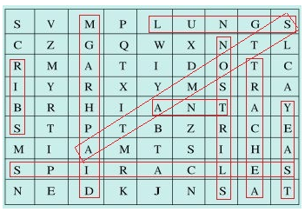  
(i) The air tubes of insects → Trachea  
(ii) Skeletal structures surrounding chest cavity → Ribs  
(iii) Muscular floor of chest cavity → Diaphragm  
(iv) Tiny pores on the surface of leaf → Stomata  
(v) Small openings on the sides of the body of an insect → Spiracles  
(vi) The respiratory organs of human beings → Lungs  
(vii) The openings through which we inhale → Nostrils  
(viii) An anaerobic organism → Yeast  
(ix) An organism with tracheal system → Ant

[9.] The mountaineers carry oxygen with them because:

(a)At an altitude of more than 5 km there is no air.

**(b)The amount of air available to a person is less than that available on the ground.**

(c)The temperature of air is higher than that on the ground.

(d)The pressure of air is higher than that on the ground.

CH-11 TRANSPORTATION IN ANIMALS AND PLANTS

Exercise Questions

**Ans.**  
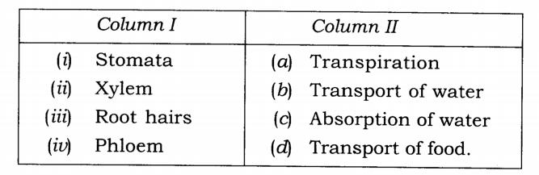

[2.] Fill in the blanks.

1)The blood from the heart is transported to all parts of the body by the **arteries**

2)Haemoglobin is present in **red blood** cells.

3)Arteries and veins are joined by a network of **capillaries**.

4)The rhythmic expansion and contraction of the heart is called **heartbeat.**

5)The main excretory product in human beings is **urea** .

6)Sweat contains water and **salts** .

7)Kidneys eliminate the waste materials in the liquid form called **urine .**

8)Water reaches great heights in the trees because of suction pull caused by **transpiration .**

[3.] Choose the correct option.

(a)In plants, water is transported through

**1)Xylem** 2)Phloem3)Stomata4)Root hair

(b)Water absorption through roots can be increased by keeping the plants

1)In the shade 2)In dim light **3)Under the fan** 4)Covered with a polythene bag

[4.] Why is transport of materials necessary in a plant or in an animal? Explain.

Solution: Transport of materials is necessary in both plants and animals as every cell needs regular supply of nutrients and oxygen for releasing energy through respiration.

The food that we eat is broken down into smaller components to be absorbed by cells. The oxygen we inhale also has to be transported to all the cells of the body. Our body also requires constant removal of waste materials such as carbon dioxide.

For the transport of all these materials (nutrients, oxygen and waste products) our body has a specialised transport system.

Similarly, in plants, the transport of water and food is accomplished with help of vascular tissues (xylem and the phloem).

[5.] What will happen if there are no platelets in the blood?

Solution: If there are no platelets, then blood will not clot as platelets release blood clotting factor at the site of injury and stops further bleeding.

[6.] What are stomata? Give two functions of stomata.

Solution: Tiny pores present on the leaf surface are known as stomata.

Functions of stomata

Helps in exchange of gases

Evaporation of water through leaves occurs due to stomata.

[7.] Does transpiration serve any useful function in the plants? Explain.

Solution: Transpiration serves the following functions in plants

It helps in lowering temperature of plants, thus preventing heat injury of plants.

Helps in transpiration pull, which helps in raining water in higher plants.

It also causes loss of water absorbed by plants.

8.] What are the components of blood?

Solution: Red blood cells, white blood cells, platelets and plasma.

[9.] Why is blood needed by all the parts of a body?

Solution: Blood is a significant part of transport system in our body, and we need blood for the following reasons:

For the transport of oxygen to all parts of our body

To expel out carbon dioxide from our body

To transmit heat thus helping in the regulation of body temperature.

It is required to fight out infections and diseases.

[10.] What makes the blood look red?

Solution: The presence of a red pigment called haemoglobin in red blood cells (RBC) makes the blood appear red.

[11.] Describe the function of the heart.

Solution: The heart is an organ which beats continuously to act as a pump for the transport of blood, which carries other substances with it. The heart has four chambers. The two upper chambers are called the atria (singular: atrium), and the two lower chambers are called the ventricles. The partition between the chambers helps to avoid mixing up of blood-rich in oxygen with the blood-rich in carbon dioxide. Blood flow from the heart to the lungs and back to the heart from where it is pumped to the rest of the body.

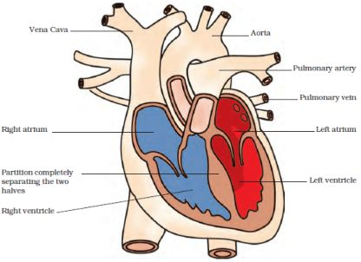

**[12.] Why is it necessary to excrete waste products?**

**Solution:** When our cells perform their functions, certain waste products are released. These are toxic and hence need to be removed from the body.

**[13.] Draw a diagram of the human excretory system and label the various parts.**

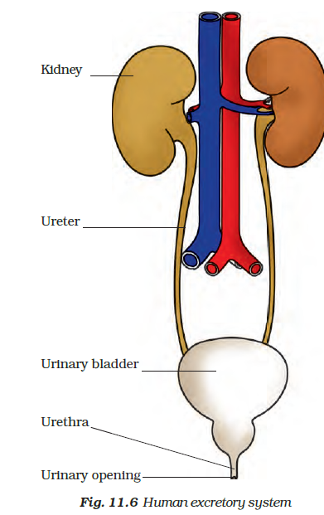

**CH-12 REPRODUCTION IN PLANTS**  
**Exercise**

**[1.] Fill in the blanks:**  
(a) Production of new individuals from the vegetative part of parent is called **vegetative propagation**.  
(b) A flower may have either male or female reproductive parts. Such a flower is called **unisexual flower**.  
(c) The transfer of pollen grains from the anther to the stigma of the same or of another flower of the same kind is known as **Pollination**.  
(d) The fusion of male and female gametes is termed as **fertilisation**.  
(e) Seed dispersal takes place by means of **wind**, **water** and **animals**.

**[2.] Describe the different methods of asexual reproduction. Give examples.**  
**Solution:** Different methods of asexual reproduction are as follows:

Vegetative Propagation

In this asexual reproduction, new plants are produced from roots, stems, leaves and buds of the individual plant.

Examples – Tuber of potato, the rhizome of ginger.

Budding

The bud is a small projection which gradually grows and gets detached from the parent cell and forms a new yeast cell. The new yeast cell grows, matures and produces more yeast cells.

Example – Yeast.

Fragmentation

In this mode of reproduction, the growth and multiplication are done by rapidly breaking down into two or more fragments. Each fragment grows into new individuals when water and nutrients are available.

Example – Algae

Spore Formation : This reproduction is done by spores which under favourable conditions germinates and develops into a new individual.Examples – Fungi like Rhizopus, Mucor, etc.

Fission

It is a type of asexual reproduction where the unicellular organism splits to form new organisms.  There are two types of fission which are

•Binary fission

•Multiple fission

Examples

Unicellular organisms that undergo binary fission are amoeba, paramecium, Leishmania etc.

Plasmodium undergoes the process of multiple fission.

**[3.] Explain what you understand by sexual reproduction.**  
**Solution:** Sexual reproduction is a method where male and female gametes fuse to form a new individual. In plants, stamens and pistils are male and female reproductive organs which bear the anthers and ovary respectively.

**[4.] State the main difference between asexual and sexual reproduction.**  
**Solution:**

|  |  |
| --- | --- |
| **Asexual reproduction** | **Sexual reproduction** |
| It requires only one parents | Requires a male and female parent |
| Daughter cells formed are identical to parents and to each other. | Newly formed offsprings show variations in comparision to the parents. |
| Special reproductive organs are not required | Special reproductive organs are required |
| Ex: Yeast, rose, jasmine | Ex: Insects, animals |

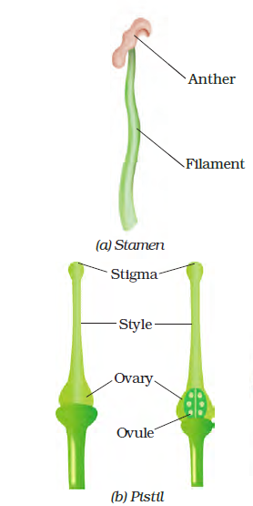[5.] **Sketch the reproductive parts of a flower.**  
**Solution:**

**6. Explain the difference between self-pollination and cross-pollination.**  
**Solution:**

|  |  |
| --- | --- |
| **Self-pollination** | **Cross-pollination** |
| In self-pollination, pollen grains are transferred from the anther to the stigma of the same flower. | In cross-pollination, pollen grains are transferred from the anther of one flower to the stigma of another flower of the same kind. |
| Self-pollination occurs only in bi-sexual flowers | It occurs in both unisexual and bisexual flowers |

**7. How does the process of fertilisation take place in flowers?**  
**Solution:**  
The process of fusion of male and female gametes (to form a zygote) is called fertilisation. The zygote develops into an embryo and embryo undergoes mitotic cell division to form seeds.

**8. Describe the various ways by which seeds are dispersed.**  
**Solution:** Seeds and fruits of plants are carried away by wind, water and animals. Winged seeds such as those of drumstick and maple, light seeds of grasses or hairy seeds of aak (Madar) and hairy fruit of sunflower, get blown off with the wind to far away places. Some seeds are dispersed by water. These fruits or seeds usually develop floating ability in the form of spongy or fibrous outer coat as in coconut. Some seeds are dispersed by animals, especially spiny seeds with hooks which get attached to the bodies of animals and are carried to distant places. Examples are Xanthium and Urena. Some seeds are dispersed when the fruits burst with sudden jerks. The seeds are scattered far from the parent plant. This happens in the case of castor and balsam.

**9. Match items in Column I with those in Column II: Column I Column II**

**Solution:**

|  |  |
| --- | --- |
| **Column-I** | **Column-II** |
| (a) Bud | (iii) Yeast |
| (b) Eyes | (v) Potato |
| (c) Fragmentation | (ii) Spirogyra |
| (d) Wings | (i) Maple |
| (e) Spores | (iv) Bread mould |

**10. Tick the correct answer:**  
**(a) The reproductive part of a plant is th**

**(i) leaf (ii) stem (iii) root (iv) flower**  
**(b) The process of fusion of the male and the female gametes is called**  
**(i) fertilization (ii) pollination (iii) reproduction (iv) seed formation**  
**(c) Mature ovary forms the**  
**(i) seed (ii) stamen (iii) pistil (iv) fruit**  
**(d) A spore-producing organism is**  
**(i) rose (ii) bread mould (iii) potato (iv) ginger**  
**(e) Bryophyllum can reproduce by its**  
**(i) stem (ii) leaves (iii) roots (iv) flower**

CH-13 MOTION AND TIME

**Exercise Questions**

**1. Classify the following as motion along a straight line, circular or oscillatory motion:**

**(i) Motion of your hands while running.** i) oscillatory

**(ii) Motion of a horse pulling a cart on a straight road.** ii) Motion along a straight line

**(iii) Motion of a child in a merry-go-round.** iii) Circular motion

**(iv) Motion of a child on a see-saw.**

**(v) Motion of the hammer of an electric bell.** iv) Oscillatory motion

**(vi) Motion of a train on a straight bridge.** vi) Motion along a straight line.

**2. Which of the following are not correct?**

**(i) The basic unit of time is second.**

**(ii) Every object moves with a constant speed.**

**(iii) Distances between two cities are measured in kilometres.**

**(iv) The time period of a given pendulum is constant.**

**(v) The speed of a train is expressed in m/h.**

**Solution:**

Incorrect statements are:

(ii) Every object moves with a constant speed.

(iv) The time period of a given pendulum is constant.

(v) The speed of a train is expressed in m/h.

**3. A simple pendulum takes 32 s to complete 20 oscillations. What is the time period of the pendulum?**

**Solution:**

Number of oscillations = 20

Total time taken to complete 20 oscillations = 32 s

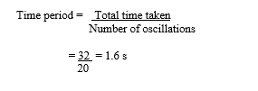

**4. The distance between two stations is 240 km. A train takes 4 hours to cover this distance. Calculate the speed of the train.**

**Solution:**

Distance between two stations = 240 kms

Total time take = 4 hrs/240 minutes

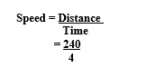

= 60 km/h

**5. The odometer of a car reads 57321.0 km when the clock shows the time 08:30 AM. What is the distance moved by the car, if at 08:50 AM, the odometer reading has changed to 57336.0 km? Calculate the speed of the car in km/min during this time. Express the speed in km/h also.**

**Solution:**

Initial reading of the odometer = 57321.0

Final reading of the odometer = 57336.0

Distance covered by the car = Final reading of the odometer – Initial reading of the odometer

= 57336.0 – 57321.0 = 15 kms

Starting time of car is 8:30 and it stops at 8: 50

Hence, time taken by car = 20 mins

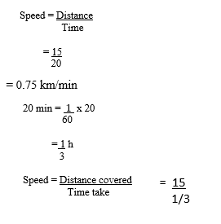

= 45 km/h

**6. Salma takes 15 minutes from her house to reach her school on a bicycle. If the bicycle has a speed of 2 m/s, calculate the distance between her house and the school.**

**Solution:** Time taken by Salma to reach her school by bicycle = 15 mins= 15 x 60 = 90 s

Speed of Salma’s bicycle= 2m/s

Speed formula

Distance covered = speed x time taken

= 2 x 900 = 1800 m

1000m = 1 km

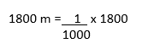

= 1.8 kms

**7. Show the shape of the distance-time graph for the motion in the following cases:**

**(i) A car moving with a constant speed.**

**(ii) A car parked on a side road.**

**Solution:**

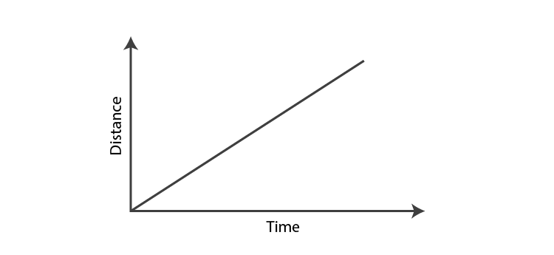  
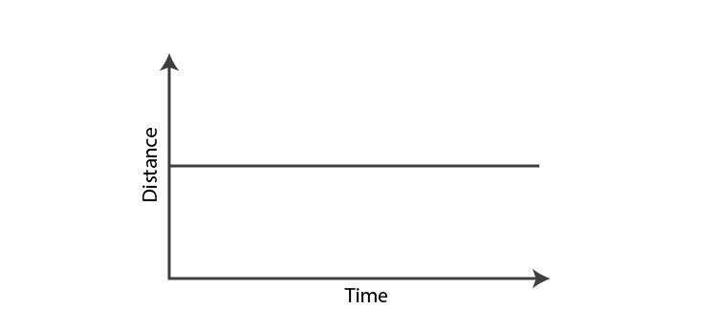

**8. Which of the following relations is correct?**

**(i) Speed = Distance × Time**

**(ii) Speed = Distance/Time**

**(iii) Speed = Time/Distance**

**(iv) Speed = 1/Distance x Time**

**9. The basic unit of speed is:**

**(i) km/min** **(ii) m/min** **(iii) km/h** **(iv) m/s**

**10. A car moves with a speed of 40 km/h for 15 minutes and then with a speed of 60 km/h for the next 15 minutes. The total distance covered by the car is:**

**(i) 100 km (ii) 25 km (iii) 15 km (iv) 10 km**

Calculation: **When the speed of the car is 40 km/h**

Time taken = 15 min = 15/60 = 0.25 h

Speed formula

Distance covered d1 = speed x time taken

= 40 x 0.25 = 10 kms

When the speed of the Car is 60 km/ h

Speed formula

Distance covered d2 = speed x time taken

= 60 x 0.25= 15 kms

Total distance covered by the car = d1 + d2

= 10 + 15

= 25 kms

**11. Suppose the two photographs, shown in Fig. 13.1 and Fig. 13.2, had been taken at an interval of 10 seconds. If a distance of 100 metres is shown by 1 cm in these photographs, calculate the speed of the fastest car.**

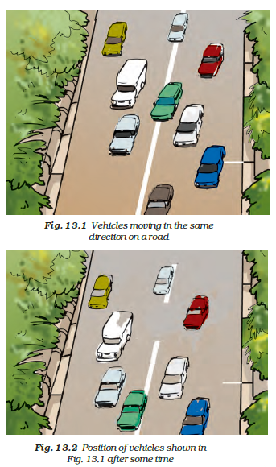

**Solution:**The distance covered by the blue car (as evident from the photograph) from one horizontal white strip to another, which is measured by scale is 1.2 cm.It is given that 1 cm is equivalent to 100 m.

Therefore, 1.2 cm is equivalent to 120 m.

Distance travelled by the car = 120 m

Time taken to cover this distance = Time interval between the two photographs = 10 s

Speed formula

= 120/10

= 12 m/s

**12. Fig. 13.15 shows the distance-time graph for the motion of two vehicles A and B. Which one of them is moving faster?**

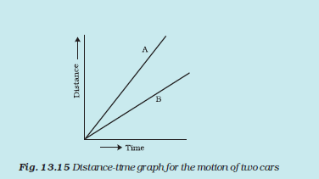

**Solution:**

Vehicle A is moving faster than vehicle B.

**13. Which of the following distance-time graphs shows a truck moving with speed which is not constant?**

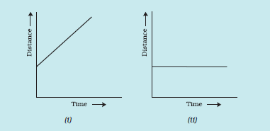  
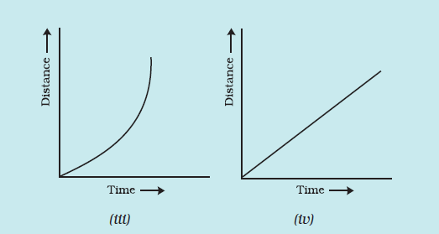

**Solution:**

Answer is iii)

CH-14 ELECTRIC CURRENT AND ITS EFFECT

Exercise Questions

[1.] Draw in your notebook the symbols to represent the following components of electrical circuits: connecting wires, switch in the ‘OFF’ position, bulb, cell, switch in the ‘ON’ position, and battery

Solution: Electric currents symbols

[2.] Draw the circuit diagram to represent the circuit shown in Fig.14.21.

Circuit diagram

Solution: Circuit diagram

[3.] Fig.14.22 shows four cells fixed on a board. Draw lines to indicate how you will connect their terminals with wires to make a battery of four cells.

Baterry cell

Solution: Completed circuit

[4.] The bulb in the circuit shown in Fig.14.23 does not glow. Can you identify the problem? Make necessary changes in the circuit to make the bulb glow.

Wrong electric circuit

Solution: In the circuit above bulb is connected on either side.

Circuit diagram

[5.] Name any two effects of electric current.

Solution: 1)Heating effect of electric current

2)Magnetic effect of electric current

[6.] When the current is switched on through a wire, a compass needle kept nearby gets deflected from its north-south position. Explain.

Solution: When the current is switched on through a wire, magnetic field is created around it hence we see deflection in the compass needle kept nearby.

**7. Will the compass needle show deflection when the switch in the circuit shown by Fig.14.24 is closed?**

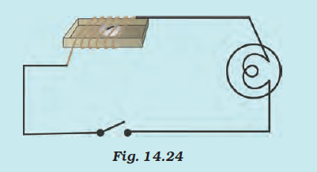

**Solution:** No , compass needle does not show deflection when the circuit is a closed, magnetic field is not created until current is flowing through the circuit.

**8. Fill in the blanks:**

(a) Longer line in the symbol for a cell represents its **positive** terminal.

(b) The combination of two or more cells is called a **battery.**

(c) When current is switched ‘on’ in a room heater, it **produces heat .**

(d) The safety device based on the heating effect of electric current is called a **fuse** .

**9. Mark ‘T’ if the statement is true and ‘F’ if it is false:**

**(a) To make a battery of two cells, the negative terminal of one cell is connected to the negative terminal of the other cell. (T/F)**

**(b) When the electric current through the fuse exceeds a certain limit, the fuse wire melts and breaks. (T/F)**

**(c) An electromagnet does not attract a piece of iron. (T/F)**

**(d) An electric bell has an electromagnet. (T/F)**

**10. Do you think an electromagnet can be used for separating plastic bags from a garbage heap? Explain.**

**Solution:**

No, because plastic does not have magnetic property to get attracted to a magnet hence magnet cannot be used to separate plastic bags.

**11. An electrician is carrying out some repairs in your house. He wants to replace a fuse by a piece of wire. Would you agree? Give reasons for your response.**

**Solution:** It is not a wise idea to replace fuse by a piece of wire, as it has very low melting point. In case of metal piece, melting point will be high and the circuit will be intact in case there is overload or overheat.

**12. Zubeda made an electric circuit using a cell holder shown in Fig. 14.4, a switch and a bulb. When she put the switch in the ‘ON’ position, the bulb did not glow. Help Zubeda in identifying the possible defects in the circuit.**

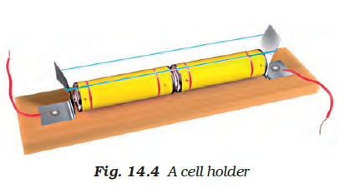

**Solution:**

Reasons may be two

i) The connecting wire may be loose

ii) The electric cell may be used up

iii) switch may not be functioning well

iv) cell power has been exhausted

**13. In the circuit shown in Fig. 14.25**

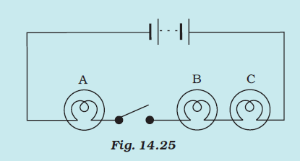

(i) Would any of the bulb glow when the switch is in the ‘OFF’ position?

(ii) What will be the order in which the bulbs A, B and C will glow when the switch is moved to the ‘ON’ position?

**Solution:** 1) No, the bulb will not glow as the circuit is not complete when the switch is off 2) If the switch is On, all the bulbs glow simultaneously.

CH-15 LIGHT

**Exercise Questions**

**[1.] Fill in the blanks:**

(a) An image that cannot be obtained on a screen is called **virtual image**.

(b) Image formed by a convex **mirror** is always virtual and smaller in size.

(c) An image formed by a **plane** mirror is always of the same size as that of the object.

(d) An image which can be obtained on a screen is called a **real** image.

(e) An image formed by a concave **lens** cannot be obtained on a screen.

**[2.] Mark ‘T’ if the statement is true and ‘F’ if it is false:**

**(a) We can obtain an enlarged and erect image by a convex mirror. (T/F)**

**(b) A concave lens always form a virtual image. (T/F)**

**(c) We can obtain a real, enlarged and inverted image by a concave mirror. (T/F)**

**(d) A real image cannot be obtained on a screen. (T/F)**

**(e) A concave mirror always form a real image. (T/F)**

**[3.] Match the items given in Column I with one or more items of Column II.**

**Solution:**

|  |  |
| --- | --- |
| **Column-I** | **Column-II** |
| (a) A plane mirror | (v) The image is erect and of the same size as the object. |
| (b) A convex mirror | (ii) Can form an image of objects spread over a large area. |
| (c) A convex lens | (i) Used as a magnifying glass |
| (d) A concave mirror | (iii) Used by dentists to see an enlarged image of teeth. |
| (e) A concave lens | (vi) The image is erect and smaller in size than the object. |

**[4.] State the characteristics of the image formed by a plane mirror**

**Solution:** Characteristics of the image formed by a plane mirror are as follows:

* Image distance and object distance are equal
* Size of object and image are equal
* The image formed is erect and virtual
* Images are laterally inverted

[5.] Find out the letters of English alphabet or any other language known to you in which the image formed in a plane mirror appears exactly like the letter itself. Discuss your findings.

Solution: A, H, I, M, O, T, U, V, W, X, Y alphabets form images in a plane mirror exactly like the letter itself because these alphabets are laterally symmetric.

**6. What is a virtual image? Give one situation where a virtual image is formed.**

**Solution:** The image that cannot be obtained on a screen is called a virtual image. The image formed by a plane mirror is virtual.

**7. State two differences between a convex and a concave lens.**

**Solution:**

|  |  |
| --- | --- |
| **Convex Lens** | **Concave Lens** |
| Thick in the middle and thin at the edge | Thin in the middle and thick at the edge |
| Image formed is real or virtual | Image formed is virtual |

**8. Give one use each of a concave and a convex mirror.**

**Solution:** Concave mirrors are used in the headlights of cars and scooters.

Convex mirrors are used as side-view mirrors in vehicles.

**9. Which type of mirror can form a real image?**

**Solution:** The **concave mirror** can form a real image.

**10. Which type of lens forms always a virtual image?**

**Solution:** **Concave lens**form a virtual image.

**Choose the correct option in questions 11–13**

**11. A virtual image larger than the object can be produced by a**

**(i) concave lens (ii) concave mirror**

**(iii) convex mirror (iv) plane mirror**

**12. David is observing his image in a plane mirror. The distance between the mirror and his image is 4 m. If he moves 1 m towards the mirror, then the distance between David and his image will be**

**(i) 3 m (ii) 5 m(iii) 6 m (iv) 8 m**

**13. The rear view mirror of a car is a plane mirror. A driver is reversing his car at a speed of 2 m/s. The driver sees in his rear view mirror the image of a truck parked behind his car. The speed at which the image of the truck appears to approach the driver will be**

**(i) 1 m/s (ii) 2 m/s**

**(iii) 4 m/s (iv) 8 m/s**

CH -16 WATER A PRECIOUS RESOURCE

**Exercise Questions**

**1. Mark ‘T’ if the statement is true and ‘F’ if it is false:**

**(a) The freshwater stored in the ground is much more than that present in the rivers and lakes of the world. (T/F)**

**(b) Water shortage is a problem faced only by people living in rural areas. (T/F)**

**(c) Water from rivers is the only source for irrigation in the fields. (T/F)**

**(d) Rain is the ultimate source of water. (T/F)**

**2. Explain how groundwater is recharged.**

**Solution:** The rainwater and water from other sources such as rivers and ponds seep through the soil and fills the empty spaces and cracks deep below the ground. The process of seeping of water into the ground is called infiltration. The groundwater thus gets recharged by this process.

**3. There are ten tubewells in a lane of fifty houses. What could be the long term impact on the water table?**

**Solution:** If ten tube-wells in a lane of fifty houses are situated, the groundwater will get used for domestic purposes. This results in depletion of groundwater level and water table would go down.

**4. You have been asked to maintain a garden. How will you minimise the use of water?**

**Solution:** We can reduce the usage of water for gardening by adopting drip irrigation method. In this method, water will reach the roots of the plant drop by drop, which will reduce the wastage of water.

**5. Explain the factors responsible for the depletion of water table.**

**Solution:** Factors responsible for the depletion of the water table are as follows:

Increase in population; Increase in population leads to increased demand for water for domestic and drinking purpose. This reduces the water table.

Industrialisation: Industries need a lot of water for manufacturing purposes. This reduces the water table.

Agriculture: Agriculture requires a lot of water for growing crops; this results in depletion of water table.

**6. Fill in the blanks with the appropriate answers:**

(a) People obtain groundwater through **tube wells** and **hand pumps**.

(b) Three forms of water are **ice, water**and **vapour.**

(c) The water bearing layer of the earth is **Hydrosphere**.

(d) The process of water seepage into the ground is called **infiltration**.

**7. Which one of the following is not responsible for water shortage?**

**(i) Rapid growth of industries**

**(ii) Increasing population**

**(iii) Heavy rainfall**

**(iv) Mismanagement of water resources**

**8. Choose the correct option. The total water**

**(i) in the lakes and rivers of the world remains constant.**

**(ii) under the ground remains constant.**

**(iii) in the seas and oceans of the world remains constant.**

**(iv) of the world remains constant.**

**9. Make a sketch showing groundwater and water table. Label it.**

**Solution:**

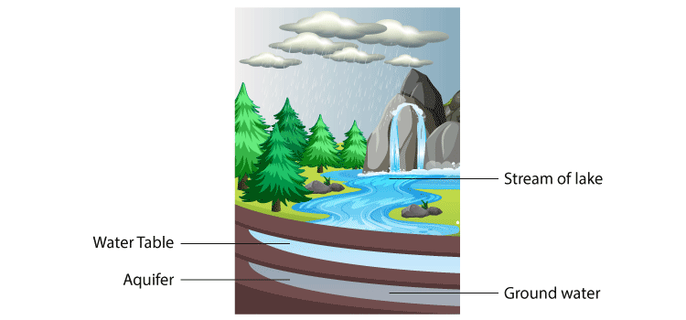

CH-17 FORESTS: OUR LIFELINE

**Exercise Questions**

**1. Explain how animals dwelling in the forest help it grow and regenerate.**

**Solution:** Animals dwelling in the forest help it grow and regenerate in the following ways

1. Animals help in dispersing plant seeds.
2. Decaying animal dung provides nutrients for plants to grow
3. Microorganisms convert the dead plants and animals to humus

**2. Explain how forests prevent floods.**

**Solution:** Plants in the forests will not allow the rainwater to fall directly on earth and these plants also hold water which helps in preventing floods.

**3. What are decomposers? Name any two of them. What do they do in the forest?**

**Solution:** The micro-organisms which convert the dead plants and animals to humus are known as decomposers. Example: bacteria and fungi. They help in recycling of nutrients by decomposing dead plants and animals.

**4. Explain the role of forest in maintaining the balance between oxygen and carbon dioxide in the atmosphere.**

**Solution:** Plants in the forests consume carbon dioxide and release oxygen by photosynthesis process. This helps in balancing oxygen and carbon dioxide in the atmosphere.

**5. Explain why there is no waste in a forest.**

**Solution:** There is no waste in a forest because waste created is bio-degradable, which gets converted to humus by the action of microorganism.

**6. List five products we get from forests.**

**Solution:** i) Medicines ii) Spices iii) Wood iv) Paper v) Gum

**7. Fill in the blanks:**

(a) The insects, butterflies, honeybees and birds help flowering plants in **pollination.**

(b) A forest is a purifier of **air** and **water**.

(c) Herbs form the**lowest** layer in the forest.

(d) The decaying leaves and animal droppings in a forest enrich the **soil**.

**8. Why should we worry about the conditions and issues related to forests far from us?**

**Solution:** We should worry about the forest for the following reasons.

1. A decrease in forest results in an increase in carbon dioxide content in the atmosphere. This results in global warming.
2. Depletion of forests results in soil erosion
3. Decrease in forest adversely affect the lives of animals living in the forest.
4. Absence of forests leads to flooding more often.
5. Due to the reduction of forest land will turn barren which is called desertification.

**9. Explain why there is a need of variety of animals and plants in a forest.**

**Solution:** Variety of plants and animals in the forests helps plants to regenerate and grow. More excellent range of plants supports herbivores, which in turn serve as food for carnivores. Decomposers turn dead animals and plants into humus; thereby maintain nutrient recycling. This wide variety makes forest a dynamic living entity.

**10. In Fig. 17.15, the artist has forgotten to put the labels and directions on the arrows. Mark the directions on the arrows and label the diagram using the following labels: clouds, rain, atmosphere, carbon dioxide, oxygen, plants, animals, soil, roots, water table.**

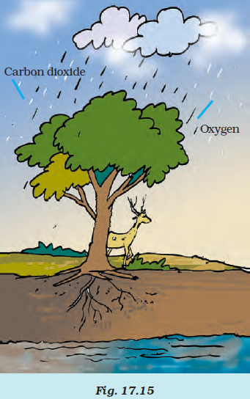

**Solution:**

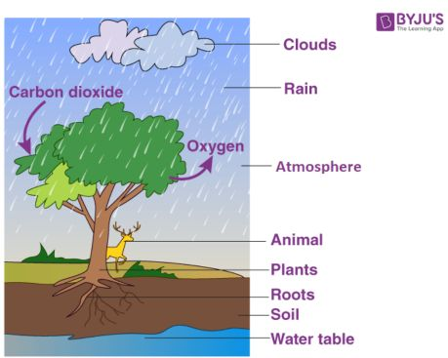

**11. Which of the following is not a forest product?**

**(i) Gum** **(ii) Plywood** **(iii) Sealing wax** **(iv) Kerosene**

**12. Which of the following statements is not correct?**

**(i) Forests protect the soil from erosion.**

**(ii) Plants and animals in a forest are not dependent on one another.**

**(iii) Forests influence the climate and water cycle.**

**(iv) Soil helps forests to grow and regenerate.**

**Solution:** Statement (ii) Plants and animals in a forest are not dependent on one another – is incorrect

**13. Micro-organisms act upon the dead plants to produce**

**(i) sand (ii) mushrooms (iii) humus (iv) wood**

**Solution:** Answer is (iii) humus

CH- 18 WASTEWATER STORY

**Exercise Questions**

**1. Fill in the blanks:**

(a) Cleaning of water is a process of removing **pollutants**.

(b) Wastewater released by houses is called **sewage**.

(c) Dried **sludge** is used as manure.

(d) Drains get blocked by **cooking oil** and **fats**.

**2. What is sewage? Explain why it is harmful to discharge untreated sewage into rivers or seas.**

Wastewater released by houses is called sewage. Untreated sewage should not be discharged into the sea because sewage consists of pollutants and harmful microorganisms which will contaminate water causing disease in people using contaminated water.

**3. Why should oils and fats be not released in the drain? Explain.**

**Solution:** Oils and fats should not be released in the drain because drains get blocked by cooking oil and fats.

**4. Describe the steps involved in getting clarified water from wastewater.**

**Solution:** Use an aerator from an aquarium to bubble air through the sample in the glass jar. Allow several hours for aeration; leave the aerator attached overnight. If you do not have an aerator, use a mechanical stirrer or a mixer. This reduces the foul smell of wastewater.

Then, the water is filtered through the layers of sand, fine gravel and medium gravel. Filtration makes the wastewater clean from various types of pollutants. The water is filtered continuously until it becomes clear.

Water is disinfected by using a chlorine tablet.

**5. What is sludge? Explain how it is treated.**

**Solution:** Solids like faeces settle at the bottom while treating sewage, and this material is called sludge. Sludge can be treated as follows:

Sludge is removed using a skimmer and then transferred to a tank where it is decomposed by anaerobic bacteria to produce biogas.

**6. Untreated human excreta is a health hazard. Explain**

**Solution:** Untreated human excreta is a health hazard because it consists of various disease-causing microorganisms and pollutants that will contaminate the soil and water resource from where people draw water for drinking and domestic purposes. When people use water contaminated with human excreta, they get diseases like Cholera, Typhoid, Dysentry and Hepatitis.

**7. Name two chemicals used to disinfect water**

**Solution:** Chlorine and Ozone are used to disinfect water.

**8. Explain the function of bar screens in a wastewater treatment plant.**

**Solution:** Bar screen removes large objects like rags, sticks, cans, plastic packets and napkins.

**9. Explain the relationship between sanitation and disease.**

**Solution:** Sanitation and disease are interrelated as lack of sanitation leads to illness and good sanitation practices prevent the diseases.

**10. Outline your role as an active citizen in relation to sanitation.**

**Solution:** Every citizen has a role to play in maintaining proper sanitisation. Following are the things we should follow to play an active role.

1. Ensure that our surroundings are kept clean.
2. The sewage system in the house should be properly managed
3. Report to the concerned authoritive immediately in case of leakages in sewage pipes.

11. Here is a crossword puzzle: Good luck!

**Across**

**3. Liquid waste products**

**4. Solid waste extracted in sewage treatment**

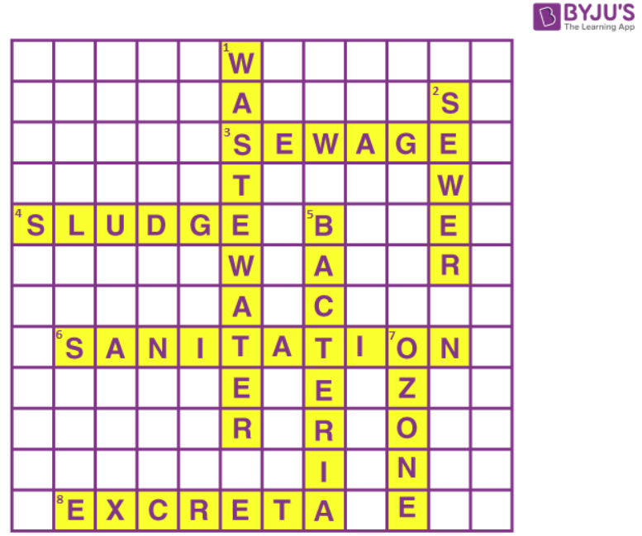**6. A word related to hygiene**

**8. Waste matter discharged from human body**

**Down**

**1. Used water** **2. A pipe carrying sewage**

**5. Micro-organisms which causes cholera** **7. A chemical to disinfect water**

**Solution:**

**Across**

3. Sewage 4. Sludge 6. Sanitation 8. Excreta

**Down**

1. Wastewater 2. Sewer 5. Bacteria 7. Ozone

**12. Study the following statements about ozone:**

**(a) It is essential for breathing of living organisms.**

**(b) It is used to disinfect water.**

**(c) It absorbs ultraviolet rays.**

**(d) Its proportion in air is about 3%. Which of these statements are correct?**

**(i) (a), (b) and (c)**

**(ii) (b) and (c)**

**(iii) (a) and (d)**

**(iv) All four**

